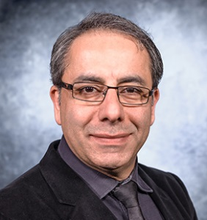

**Dr. Babak Fahimi** received his B.S. and M.S. degrees in Electrical Engineering with the highest distinction from the University of Tehran, Iran in 1991 and 1993 respectively. He earned his PhD in Electrical Engineering from Texas A&M University in 1999. Currently, He is a Distinguished Chair in Engineering and the Director of the Renewable Energy and Vehicular Technology at the University of Texas at Dallas. Dr. Fahimi has been the recipient of DAAD scholarship (1993-1995), IEEE R.M. Bass Power Electronics Young Investigator Award (2003), SAE Ralph Teetor Educational award (2008), Fulbright scholarship in 2010, and IEEE Cyril Veinott electromechanical energy conversion award in 2015. Dr. Fahimi has co-authored over 400 scientific articles, 15 book chapters, and several technical reports in the general area of adjustable speed motor drives and power electronics. He holds 24 US patents and has 6 more pending. Dr. Fahimi has supervised 36 PhD (Four tenured/tenure track professors) and 24 M.S. students. He is a Fellow of IEEE for his contributions to modeling and analysis of adjustable speed ac motor drives.

**Tutorial**:

**Contactless Power Transfer**

Dynamic contactless charging is a viable alternative for widespread introduction of electrified automobiles globally. This multidisciplinary technology that combines solutions from civil, mechanical, electrical, and material science can substantially mitigate the environmentally harmful need for Lithium while eliminating the need for carrying expensive and dangerous battery energy sources on the board of vehicles. The multi-physics nature of the problem calls for a thorough understanding of the fundamentals of operation, existing technologies, and principles of design as well as engineering challenges and opportunities.

This tutorial highlights recent advances in stationary and dynamic wireless charging of electric vehicles. A comprehensive review of charging pad, power electronics configurations, compensation networks, controls, and standards is presented. Examples from modeling and experimental verifications will be included to shed light on the know-how in development of wireless charging systems and their optimal operation.

This tutorial is intended for practicing engineers in the industry and graduate students in academia. Examples from ongoing implementations and ongoing research will be offered to provide an insightful understanding of the topic for the audience. The talk is designed for 2.5 hours followed by 30 minutes of clinic session to engage the audience and address potential questions.